This document will guide you through the process of ordering your child’s test. Please read this page carefully before ordering.

EACH TEST REQUIRES A UNIQUE PROFILE. EACH CHILD WILL NEED A UNIQUE EMAIL ADDRESS ASSOCIATED WITH THE ACCOUNT YOU CREATE WHEN ORDERING. If your child does not have an email, please create an email for each child you are ordering a test for. See instructions on page 2.

1 ACCOUNT = 1 TEST
*DO NOT ORDER MULTIPLE TESTS UNDER 1 ACCOUNT

To order a test for your camper, please use the following link: https://h.vlt.co/camp
- Only order using this link, if you attempt to order through the main website you will not be able to order a test.
- Google Chrome browser strongly recommended.

Important details about the test:

- YOUR RECEIPT FOR INSURANCE PURPOSES WILL BE DELIVERED ON THE SAME DAY AS YOUR RESULT.
- Each test kit will be uniquely registered to a specific child. Please make sure not to swap kits with other members in your household.
- There is no appointment required to perform the sample collection, simply login to the account created while ordering each test and enter a zoom waiting room on the day your camp director designates for testing. Instructions are included with your test.
- Do not open the test tube packaging until you’re ready to do the saliva collection with your child over a Zoom video call. Spitting into the tube prior to the telehealth visit will invalidate your sample.
- You need to accompany your child for the supervised saliva collection.
- When your child is ready to do the saliva collection, login to the Zoom waiting room using the email and password you signed up with.
- Children should not eat, drink, or chew gum for at least 30 minutes before giving the sample.
- Ship the test back before 3pm local time on the day of testing.. You can locate a drop off point here.

It is your responsibility to adhere to the schedule provided by your Camp Director for ordering the test and performing the saliva collection in advance of your child’s arrival at camp. If you miss a deadline, please escalate this to your Camp Director.

If you have any questions or need assistance with your test please reach out to us at covid@vaulthealth.com or call 212-880-5494.
ORDERING TESTS FOR MULTIPLE CHILDREN

If you have multiple campers in your household, we recommend using incognito mode in google chrome. (To open incognito mode, right-click on the google chrome icon and select “new incognito window”, then enter the test ordering link). When ordering a second test, open a new incognito tab and re-enter the link.

If you do not have an existing email that you can use for your child, there are two options for creating additional emails for your child/children.

  - Option 1: You can create a new email address for your child. We suggest creating an email account through Gmail. Gmail accounts are free, secure, and should take less than 5 minutes to create.
  - Option 2: If you yourself have a Gmail account, you can create a unique ‘version’ of your email for your child by using the plus sign (+). All emails sent to that email address will be forwarded to your email address.
    - For example, if your email is johndoe@gmail.com, you can create a ‘new’ email for your child by adding a “+” sign and introducing any text between the + sign and the “@” sign. (E.g. “johndoe+childname@gmail.com, ) Any emails sent to “johndoe+childname@gmail.com” will automatically forward to your inbox.
    - You can read more about this here.

- Your child’s results notification will go to the email used to create their account. Please ensure that you have access to the email account in order to retrieve the result notification. If you are using the + symbol to create another account the results notification will be sent to the ‘original’ address.

- After completing the account creation, enter information specific to the child you are ordering for throughout the remainder of the process.

- Be sure to record the account details for each child, you will log into each account on the testing day to join a zoom waiting room and have your test observed by a Vault provider. https://app.vaulthealth.com/login?redirectUrl=https://app.vaulthealth.com/account

The following pages provide a step by step guide to ordering a test for your child:

Step 1

- The first page of the website will ask for information about your child. Please make sure not to enter parental information here, there will be a subsequent page where you will enter that info.

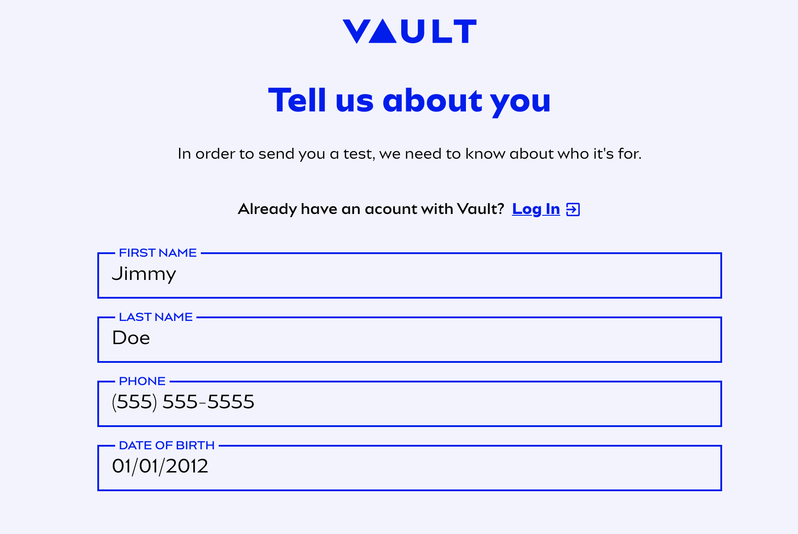

Step 2

- Each child will need a unique email address associated with the account you will create when ordering the test. If your child does not have an email, please create an email for each child you are ordering a test for.

- If you do not have an existing email that you can use for your child, there are two options for creating additional emails for your child/children.
  - Option 1: You can create a new email address for your child. We suggest creating an email account through Gmail. Gmail accounts are free, secure, and should take less than 5 minutes to create.
  - Option 2: If you yourself have a Gmail account, you can create a unique ‘version’ of your email for your child by using the plus sign (+). All emails sent to that email address will be forwarded to your email address.
    - For example, if your email is johndoe@gmail.com, you can create a ‘new’ email for your child by adding a “+” sign and introducing any text between the + sign and the “@” sign. (E.g. “johndoe+childname@gmail.com, ) Any emails sent to “johndoe+childname@gmail.com” will automatically forward to your inbox.
    - You can read more about this here.

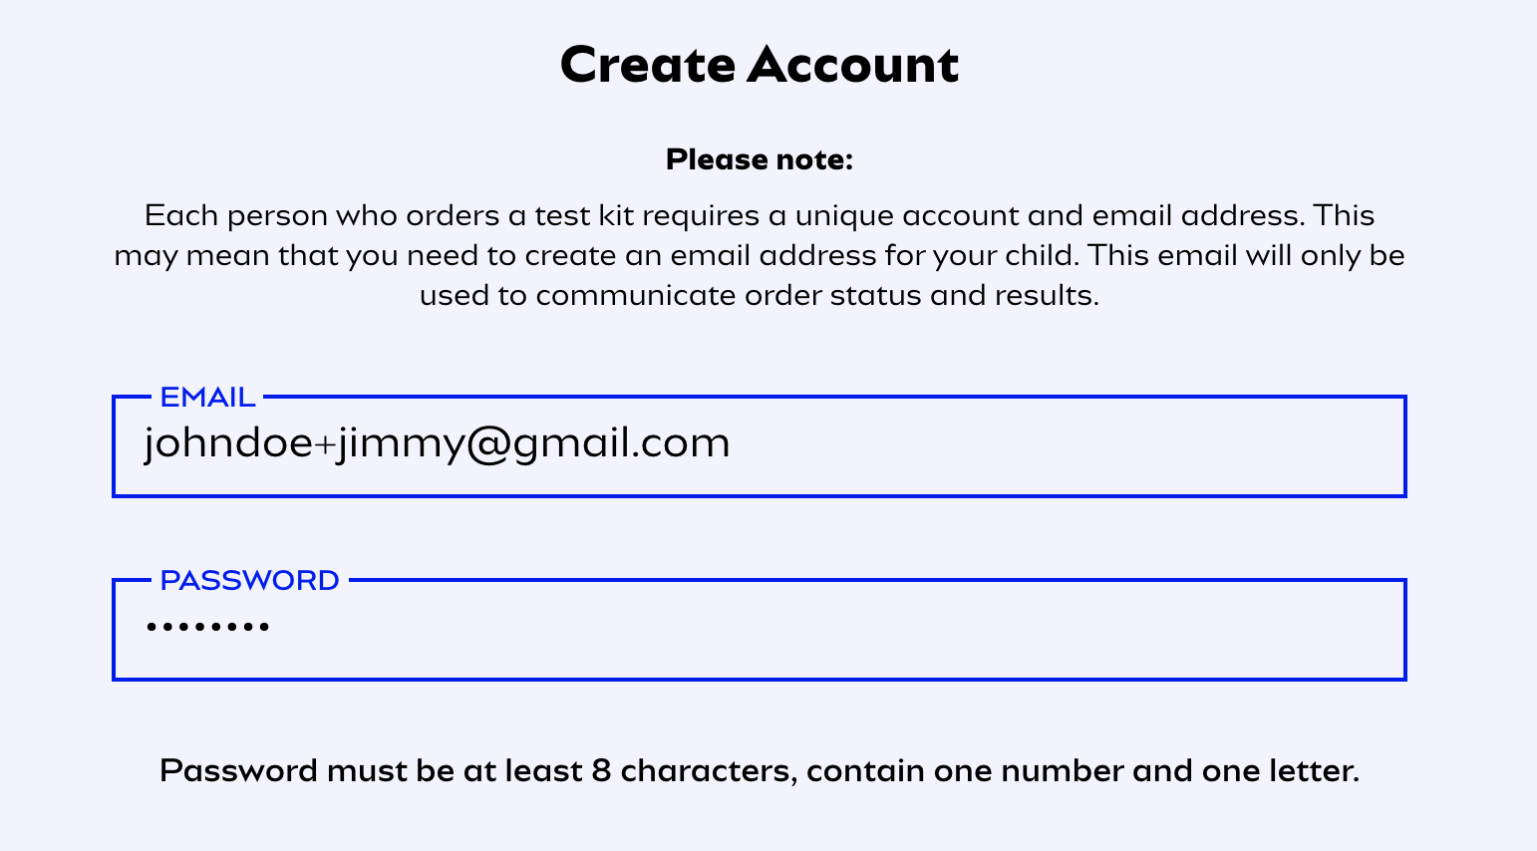

- Your child’s results notification will go to the email used to create their account, please ensure that you have access to the email account in order to retrieve the result notification. If you are using the + symbol to create another account the results notification will be sent to the ‘original’ address.

Step 3

- On the next page, enter your first and last name under Parent/Guardian Details.
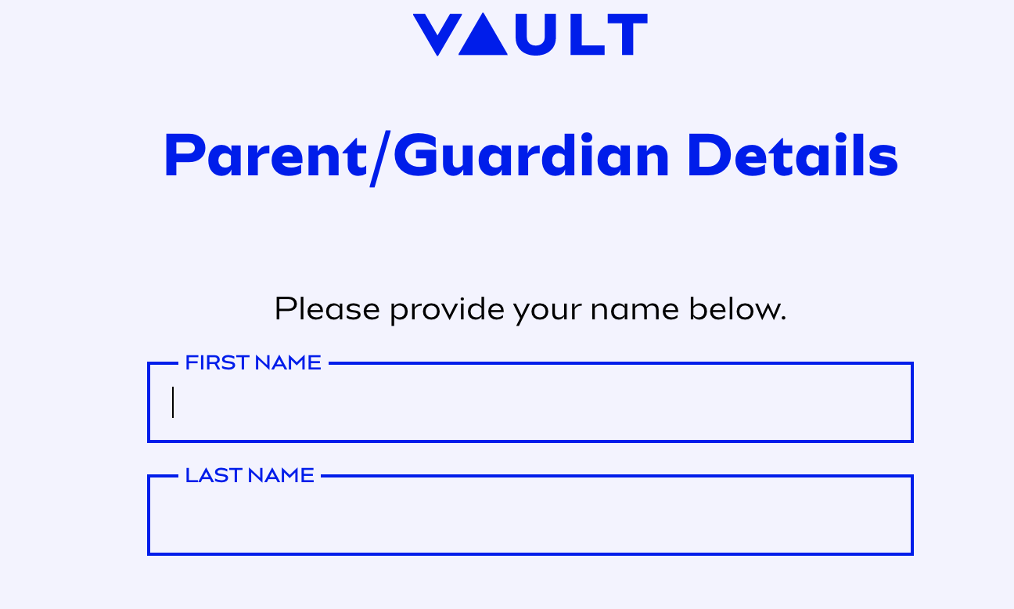
Step 4

- Next, take a photo or upload a photo of the PARENT or GUARDIAN’S government issued photo ID. This should be your ID, not the child’s ID. Please make sure that the ID is well-lit and clearly readable.

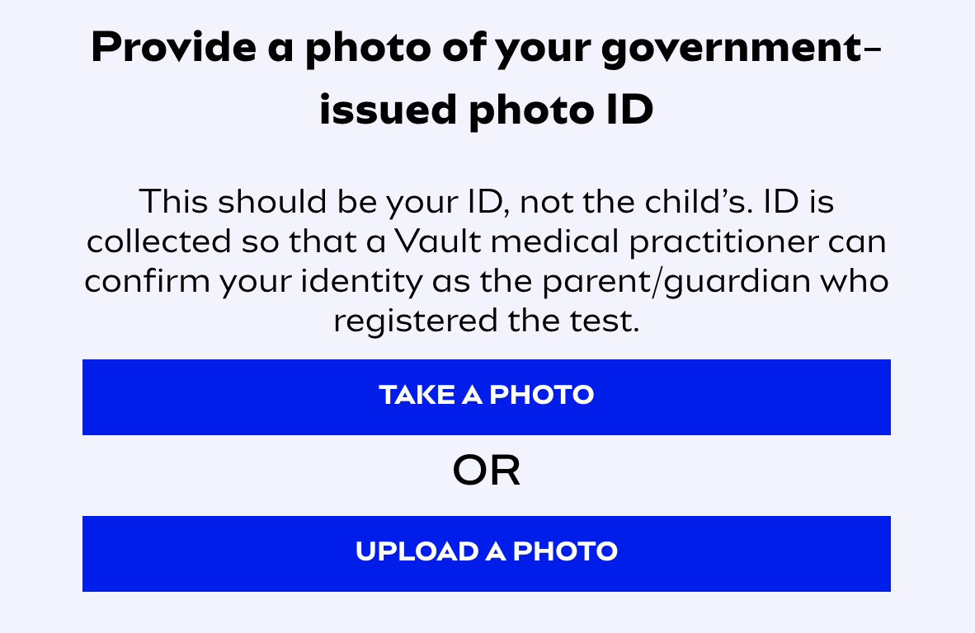
- After taking or uploading the photo, click the consent checkbox and click “Next.”

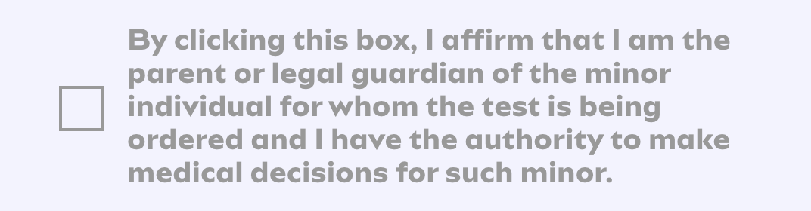

Step 5

- On the next page, click whether or not you and your family are enrolled in Medicare or Medicaid.
  - Select “No”

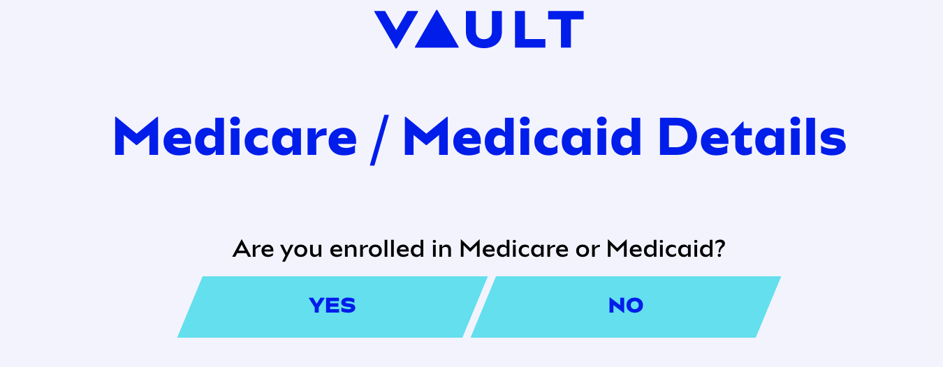

Step 6

- Next you will select the state where you would like your testing kit shipped

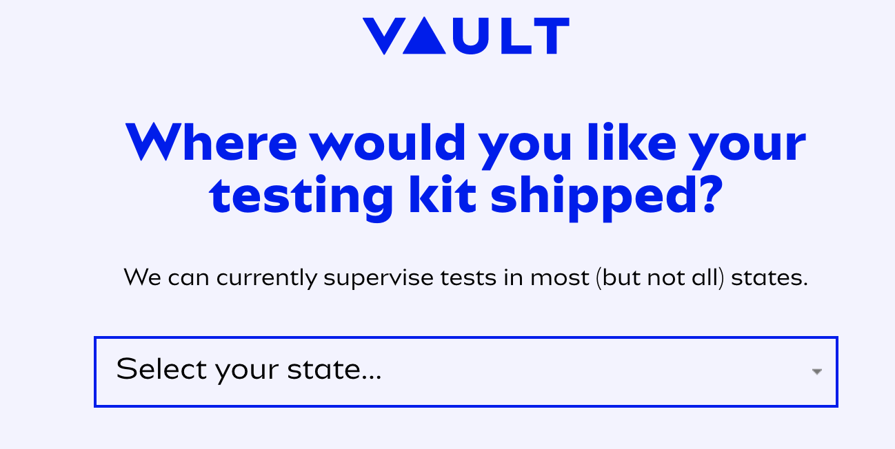

Step 7

- Please review the test guidelines and click the appropriate checkboxes at the bottom of the page. Note: This test does not require a separate physician order. The test will be ordered by a Vault Physician following your completion of the intake forms. Your only responsibility is to complete the intake process.
  - Receiving the results of the test via email is optional. If you do not click the checkbox for this option, you’ll need to log in to your account to view the results (vaulthealth.com/covid)

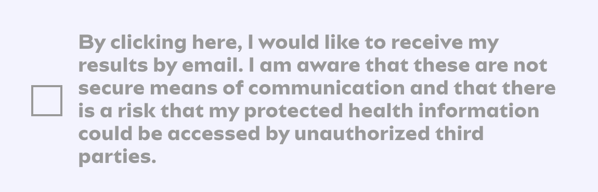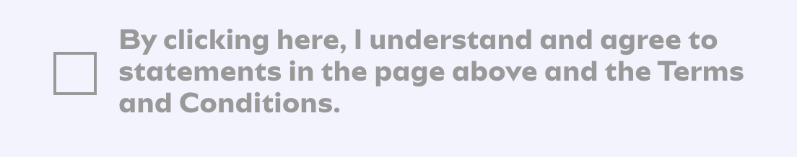

Step 8

- Next you will be asked if your child has been exposed to anyone who has been confirmed to have COVID-19.

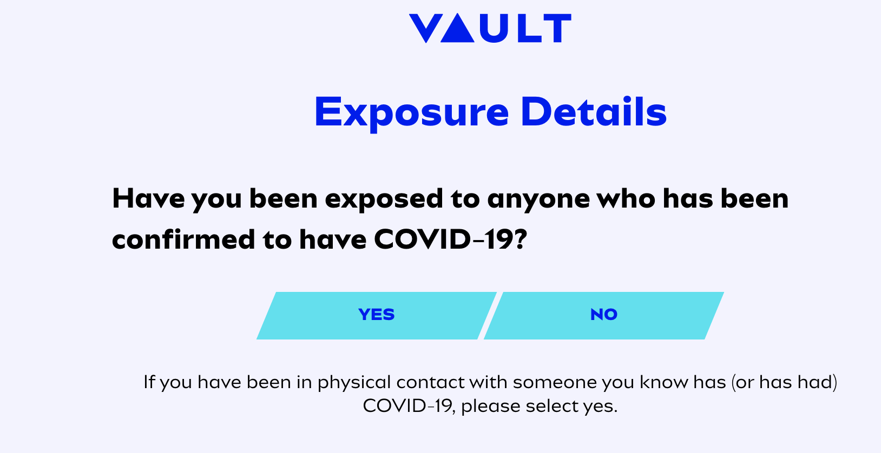

- If your child has been exposed to someone you will be asked to provide the number of days since exposure.
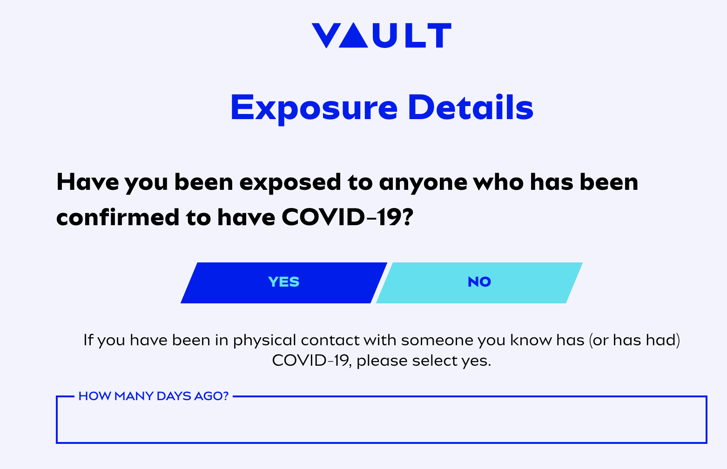

Step 9

- Next you will be asked if your child has potentially been exposed to someone with COVID-19. If yes, please indicate the number of days since exposure.

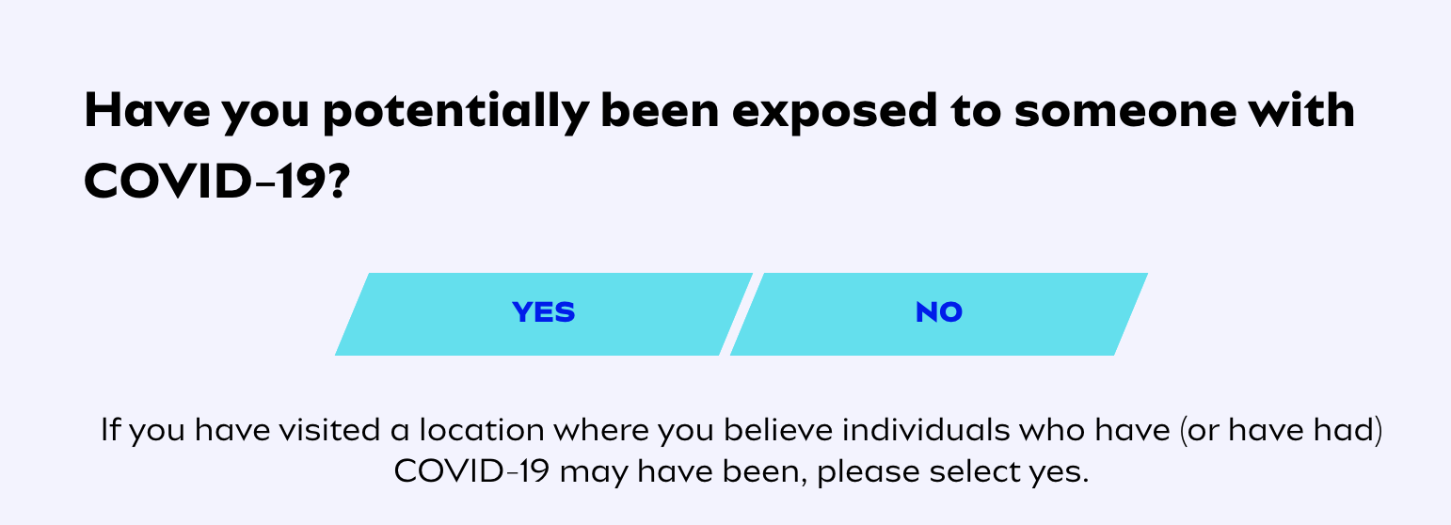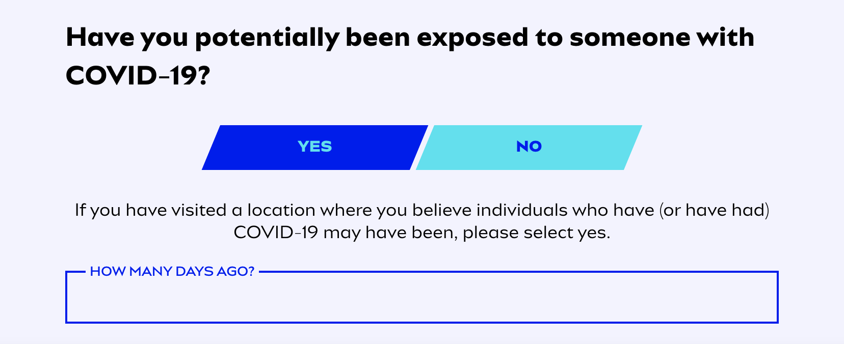

Step 10

- Next you will indicate whether or not your child is experiencing any symptoms of COVID-19. If they are not experiencing any symptoms, select the “No Symptoms” option.

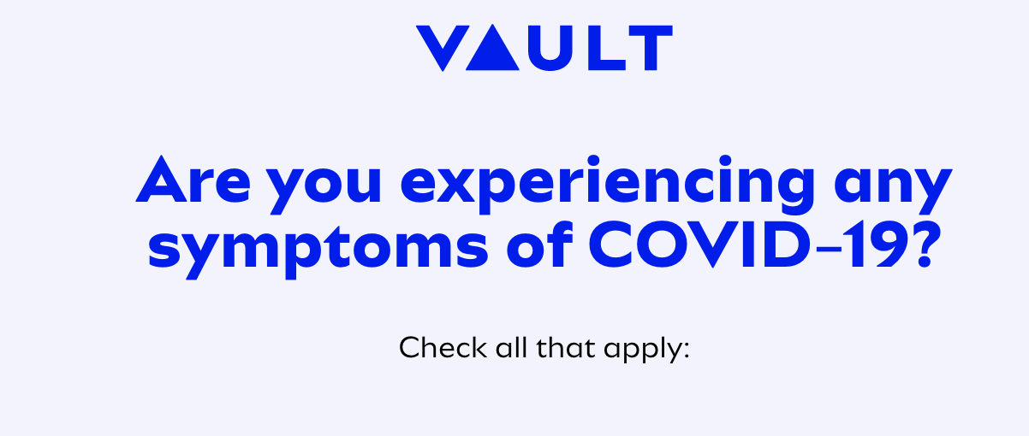
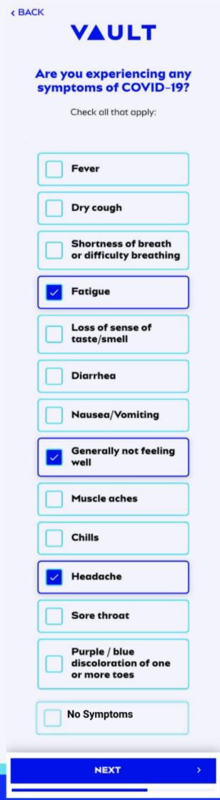

- If you indicated any symptoms, you will then be asked how many days your child has had symptoms for. Please enter the number of days.

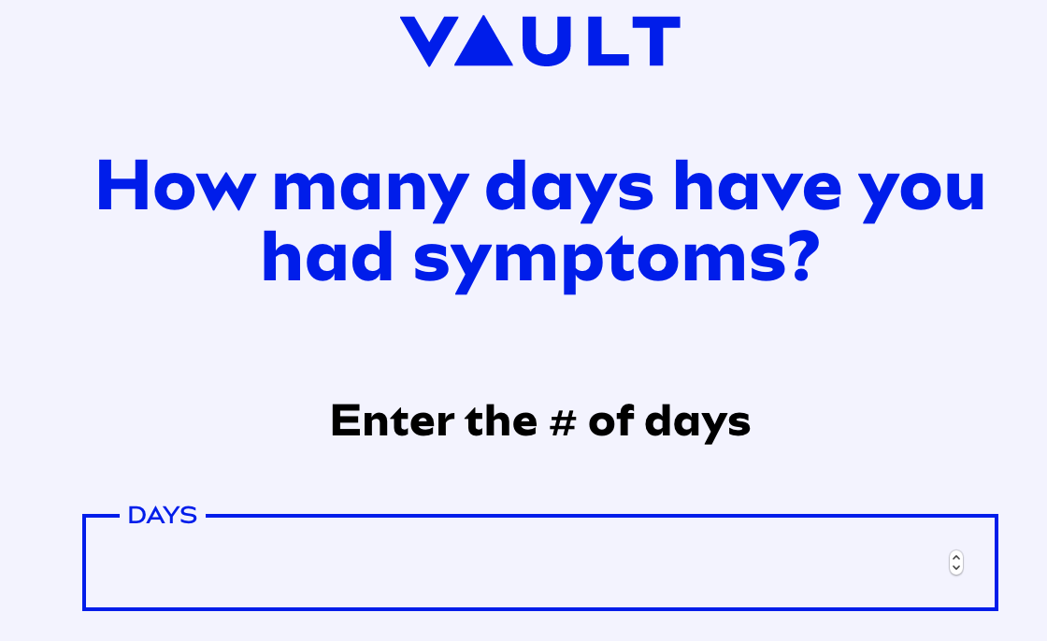
Step 11

- Enter the shipping address where you will receive your test and click “Next”. Note that the address must be in the state you selected previously.

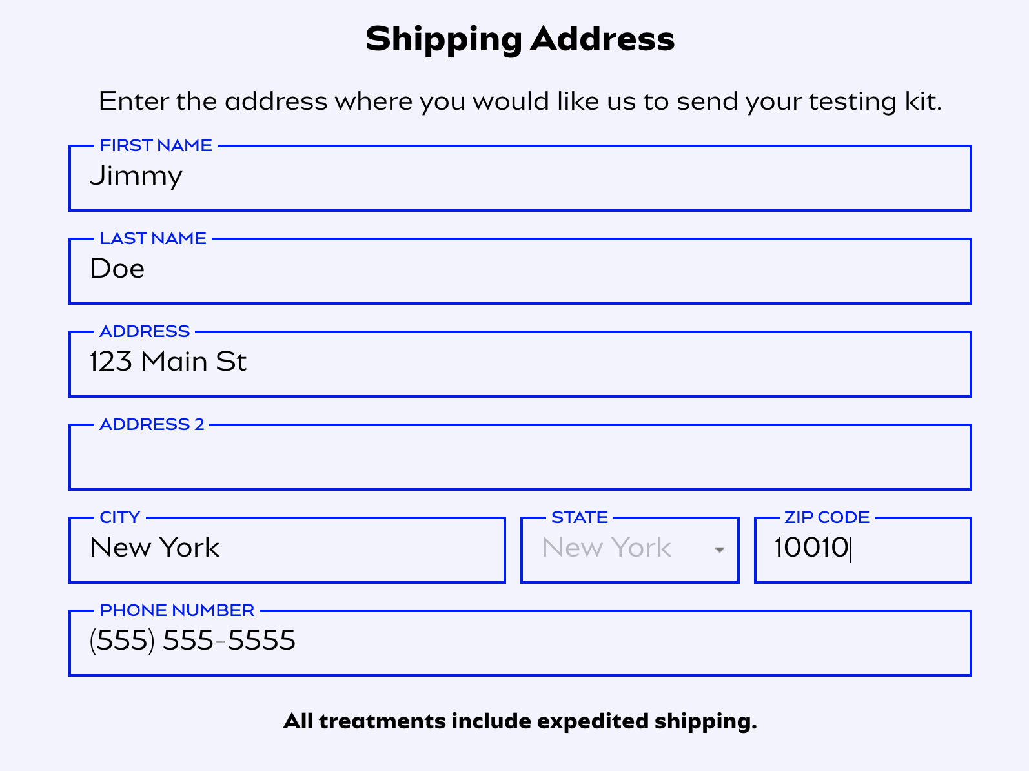

- Enter your payment information. If your billing address is the same as your shipping address, click the “Same as Shipping Address” checkbox. Then click “Next.”

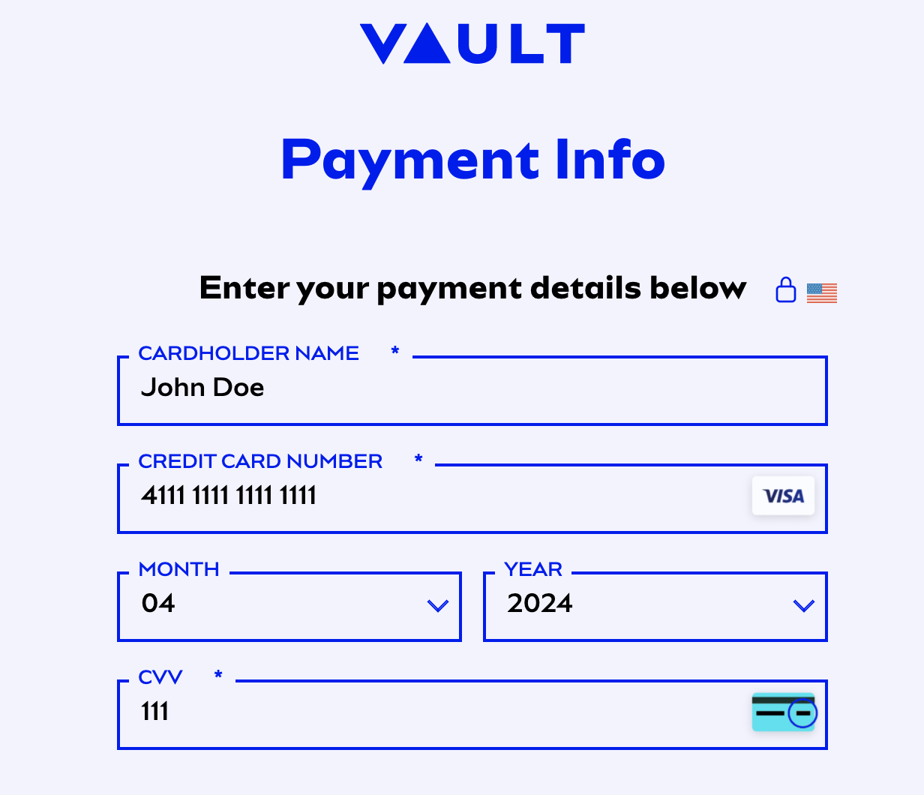
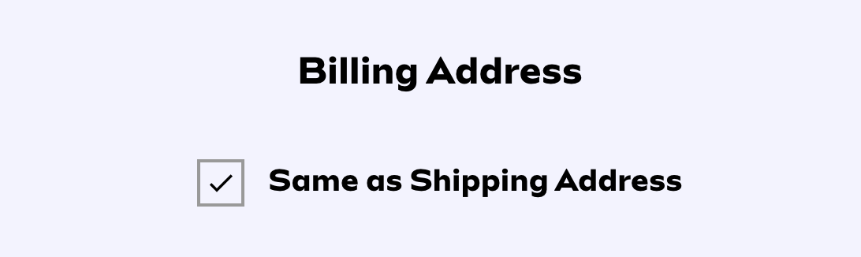

- If your billing address is different from your shipping address, enter your billing address.

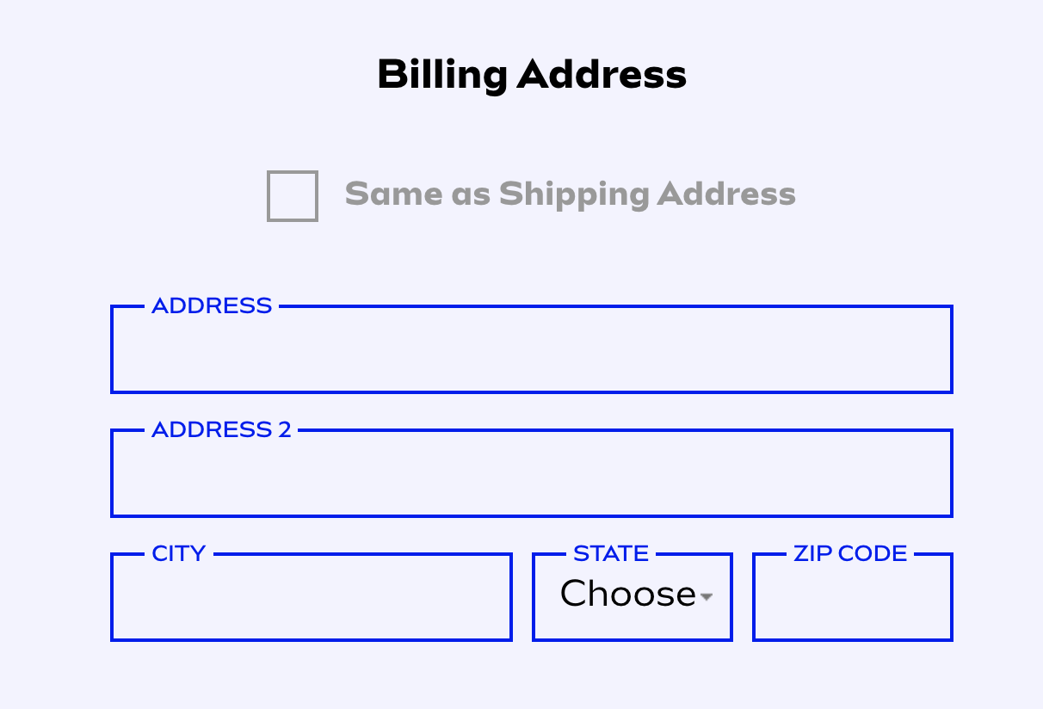

Step 12

- After reviewing your order, click “Place Order” at the bottom of the page. If you need to make any changes, click the “Back” link in the upper left corner of the page.

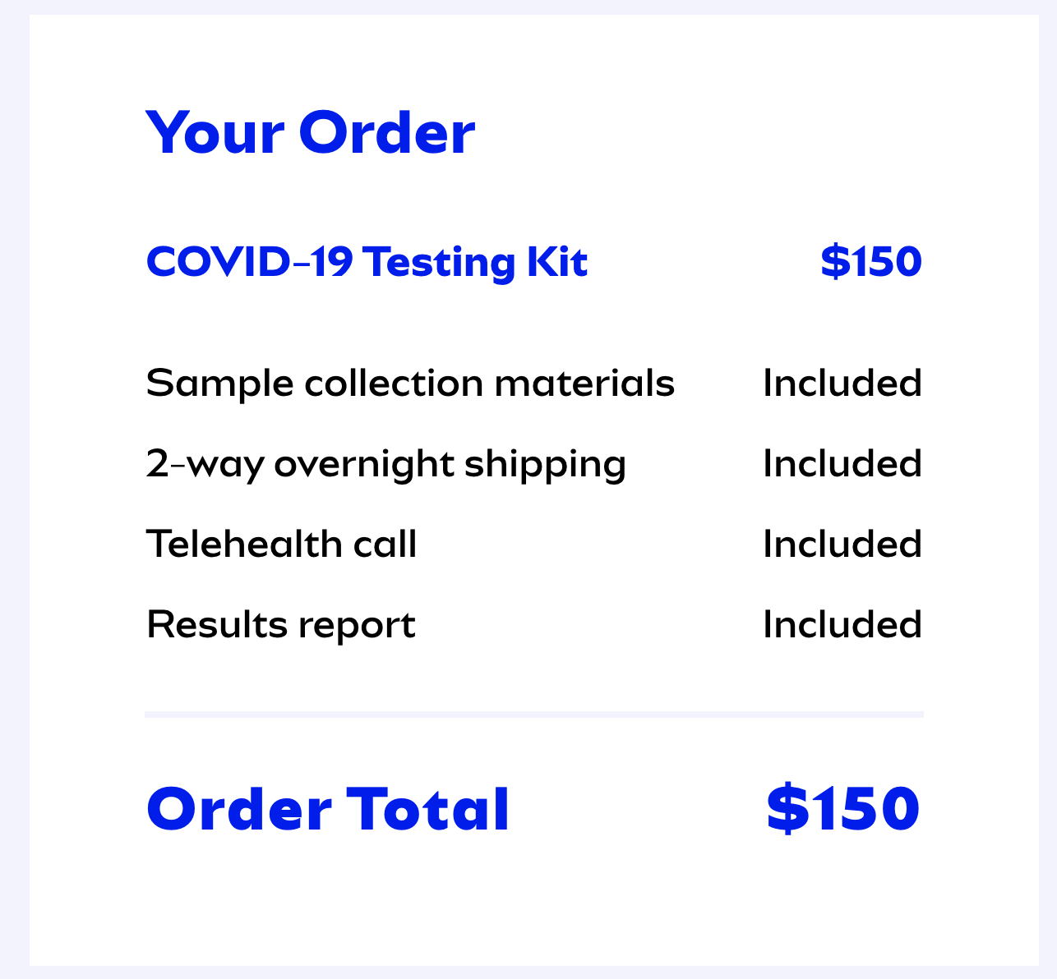
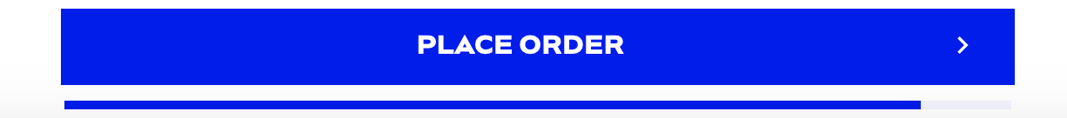

You’ll receive an order confirmation email. On the day of testing, login to the account you created while ordering the test at https://app.vaulthealth.com/login to join a zoom waiting room and perform the sample collection.

Test Summary:

Vault Health is excited to work together with camps nationwide to help campers and staff enjoy camp throughout the summer. In partnership with Rutgers Clinical Genomics Laboratory (RUCDR), we developed a process to conduct physician-ordered testing using a provider-supervised telemedicine collection of a saliva specimen (at home), with physician-managed results reporting provided directly to the patient as well as applicable health authorities. This test protocol eliminates the risk of provider-to-patient exposure and eliminates waste of scarce personal protective equipment (PPE). Use of a saliva sample also helps patients avoid the potential discomfort of producing a sample with a nasopharyngeal swab.

The test can detect fewer than 10 copies of viral genes per milliliter of saliva, and can detect the presence of virus in the saliva within 2 days of infection and up to 28 days after infection. Across all known gene sequences of SARS-CoV-2, the test detects the ones in the genes of interest >99% of the time, making it highly sensitive and specific for those genes.

Furthermore, emerging data about false negative rates of saliva-based COVID tests are showing that the false negative rate for saliva-based tests are in the 0-10% range, which is significantly lower than those of nasopharyngeal swab-based tests, which are in the 25-35% range.

